*Solar Desalination for the Galápagos*

Aram Andriesian, Nicholas Babcock, Shaun Crippen, & Nathan Curti

REE412: Photovoltaic Systems

Oregon Institute of Technology

Wilsonville, Oregon

*Abstract*—A 50-kW, photovoltaic-powered, reverse osmosis, water desalination system was designed to deliver at least three liters per day of fresh potable water to the 12,000 residents of Puerto Ayora, Santa Cruz, in the Galápagos Islands of Ecuador. This contributes to Ecuador’s Galápagos Islands Zero Fossil Fuels initiative, as well as the humanitarian effort of providing sanitary drinking water to those without. The system utilizes 945 solar panels, a 181,000 l/day capacity reverse osmosis system, three hours of backup battery power, and tank storage of a seven day supply of water. The initial cost is estimated at $576,000.

# OBJECTIVE

The purpose of this project is to design a photovoltaic (PV)-powered, water desalination system to supply potable water to the 12,000 residents of Puerto Ayora, Santa Cruz, in the Galápagos Islands of Ecuador [1]. The proposed system is a 50-kW reverse-osmosis (RO) system which delivers at least 36,000 liters per day, enough for three liters per day per resident. This proposal serves both the vital humanitarian effort of providing water security, and the fundamental global necessity of mitigating climate change.

# JUSTIFICATION

Despite the fact that Puerto Ayora is the most populated community in the Galápagos, the people must still resort to drink brackish water at times, ultimately compromising their health. The only source for clean water in the city is a private producer, which can produce a limited amount of clean water at $0.0946 per gallon. This is very expensive, even compared to the high cost of water in Los Angeles, which is $0.00775 per gallon, and especially considering the respective average incomes. The cost for Puerto Ayora is over twelve times higher than Los Angeles, which is in a densely populated state with historical drought issues [2], [3]. This high cost is in part due to the high cost of electrical power, which is provided by diesel generators, contributing heavily to fossil fuel consumption and carbon dioxide emissions, along with other pollution.

This is also an opportune time to implement solar and other renewable projects because of Ecuador’s Galápagos Islands Zero Fossil Fuels Initiative. Passed in 2007, this is the goal set by the Ecuadorian government to completely remove fossil fuels from the Galápagos Islands by 2020 [4]. This political trend would allow for better acceptance and funding of this proposal by the Ecuadorian government and its people.

Not only does Puerto Ayora have the need and political incentive, but the area also has an exceptional solar resource. Being close to the equator, at 0.8° S latitude, the climate and solar exposure are nearly constant throughout the year. Having a constant climate is advantageous when designing a photovoltaic system because the performance will not change appreciably throughout the year. This is especially important considering the system’s vital function of providing power to a water desalination system serving a large population. Also, the consistent insolation means the PV system need not be oversized for one season in order to serve the loads during the season of lower insolation. The annual average of daily insolation is six peak sun hours per day, and the monthly average varies by only 8% during the year. The average monthly solar irradiation varies from 458 W/m2 to 540 W/m2, with an average of 500 W/m2 [5]. Being close to the equator also allows the sun path to be high in the sky, where the sun is at least 45° above the horizon from 9 am to 3 pm solar time [6]. This high sun path allows for freedom of PV array placement, as there are few obstructions that would block the sun. There are no large existing structures in the community and the project location is an open beach area. A table of meteorological data and a sun path map are included in the appendix (A2).

# DESIGN

Design calculations are included in the appendix (A1) as is a layout schematic (A4). The design of the solar desalination system began with determining the electrical load on the photovoltaic system. This began with the selection of the water desalination process, the primary load. Reverse osmosis (RO) was selected because it had a significantly higher energy efficiency than other processes, as well as low energy demand [7]. With the process selected, the size of the RO system was determined. The system needs to provide a minimum of 36,000 liters (9,500 gallons) per day. Puerto Ayora however has an annual average of only six peak sun hours a day, requiring the system to produce the 36,000 liters in 6 hours. The system must then be able to deliver fresh water at a rate of 6,000 liters (1585 gallons) per hour. The RO system selected was the SW-48K-2680 from Pure Aqua. This manufacturer was selected because the system, including all its required equipment, pre-treatments, and post-treatments, is assembled in a self-contained metal container that is also equipped with an air-conditioning unit for removal of waste heat. The unit size was selected because it has the lowest delivery rate that meets the minimum water requirement. The SW-48K-2680 RO system produces 12,000 gallons per 6 peak sun hours (an average day in Puerto Ayora). With the minimum needed quantity of 9,500 gallons a day, the system provides 126% of the requirement. This is a good safety factor, especially when considering the tropical climate of Puerto Ayora [8]. This serves as a good buffer for times of lower than average insolation. Detailed RO system information is contained in the datasheet and supplier quote in the appendix.

The other loads on the solar system are the feed pump and outlet pumps. The feed pump will pull untreated water from a stilling well which provides some natural pre-filtering of ocean water through the sand. The outlet pump will transfer the desalinated drinking water from the RO system to the storage tank. The RO system has a recovery rate of 50%, meaning that the intake pump has to provide double the amount of saltwater than the maximum amount of freshwater the RO system produces, which equates to 4,000 gallons per hour. The Dometic P3600B3X was selected because it provides 4,200 gph, is rated for seawater, and is economically priced [9]. The RO outlet pump needs a flowrate at least equal to the RO system maximum output, meaning a minimum of 2,000 gph. The outlet pump selected was a Dometic PS3000B3X. The pump was chosen because it had the best price for a seawater rated pump that met the flowrate requirements, providing 3000 gph, and matching the power requirements of the other pumps in the system [10]. The saltwater feed pump to deliver the brackish water and the freshwater pump are sized for a head of 20 feet for the saltwater pump and 30 feet for the freshwater pump for a total head of 50 feet to provide water pressure for distribution that may be connected to the storage tank. Both pumps are rated for 30 feet of head with the saltwater pump being oversized to prevent cavitation near the inlets of the other pumps, and to overcome head loss through pre-filters. These pumps along with the RO system power requirements led to the total electrical load of approximately 48 kW.

Included in the load are small pumps and controls that are used in water pretreatment, along with the air conditioner. They run on 110 VAC, which is less than the rest of the system, which runs on 480 VAC. To accomodate this a Square D 2S8F 277 V-120/240 V transformer will be included to bring the voltage down to a safe level for the pretreatment pumps, and other 110-VAC loads [11].

With the total load on the photovoltaic system known, the next step to select an inverter that would effectively turn the DC power of the solar modules and batteries to the AC power required for the load. The Solectria PVI 50KW inverter was selected because it provided output needed as having a built-in boost converter, allowing for varying PV array and battery bank voltages [12].

The next step in the design process was to size the battery bank. After looking at various battery chemistries, LiFePO4 lithium-ion was selected. The decision was made because the battery technology offered the combination of very high energy density and cycle life expected in lithium-ion batteries, but also has the advantage of being a safer lithium technology and is similar enough to lead-acid batteries to be interchangeable. AA Portable Power’s LFP-G100 3.2 V, 100 Ah cell was selected, because it was the most economical LiFePO4 battery to meet the needs of the system. Lithium batteries also had the advantage of being able to handle deeper discharges, with LiFePO4 allowing for 80% depth of discharge (DOD) with excellent cycle life of over 3000 cycles (at 80% DOD) [13] When compared to the much lower cycle life and the shallower preferred DOD of lead acid batteries, it becomes clear that for long-term applications, these LiFePO4 batteries are much more economical. For example, the absorbed glass mat (AGM) batteries that were first considered (model UB4D) would require much fewer batteries at just over half of the initial cost. However considering the cycle-life of only 500 cycles (with merely 50% DOD), the yearly replacement cost is over three times as high. As shown in figure 1, the choice of LiFePO4 begins to save substantial cost after just a few years. This assumes 250 cycles per year, and average yearly replacement costs set aside each year. Also this assumes that the prices will remain constant, however being a somewhat newer technology, the cost versus capacity of LiFePO4 batteries is likely to decrease, making this choice even more economical.

Figure 1. Total battery cost accrued over 24 years.

With the cell selected, the battery bank was then sized. The inverter requires an input voltage of between 300 VDC and 500 VDC for maximum power conversion, and an absolute maximum of 600 VDC. For the 50-kW RO system (including external pumps), this means a range of 100 A to 167 A, depending on the voltage of the battery bank. The battery bank was sized to provide a just three hours of autonomy. The main purpose of the battery bank is to provide constant power to the RO system when intermittent clouds are present which is frequent and short-lived on a typical Puerto Ayora day. This is enough energy to protect the pumps from frequent cycling and to keep the system operating during the day. Since the battery voltage decreases slightly while discharging, it is preferred to design for a charged bank voltage near the upper range of the inverter maximum power input voltages. Knowing the inverter and load requirements, the battery bank was determined to be 156 batteries in series and 4 batteries in parallel, for a total of 624 batteries.

With this many batteries however, the power ratings are too large of typical MPPT charge controllers, and would require special high power charge controllers that would unnecessarily increase the price of the system. The largest MPPT controller available at a reasonable price was the Conext MPPT 80 600 by Schneider Electric, which is rated for an array voltage of up to 600 VDC and a current of up to 80 A [14]. This means that two charge controllers are needed and that the battery bank must be split into two banks, each with 156 batteries in series and 2 in parallel, each served by one of the two charge controllers. This configuration would keep the power at reasonable levels that would protect the charge controllers, as each battery bank will be 499.2 V and 156 AH at 80% depth of discharge. The extra voltage ensures that at 80% depth of discharge the battery bank will still provide enough voltage to the inverter and keep the current at safe levels for the charge controllers and provide the desired 3 hours of autonomy.

The primary form of storage for the desalination system was the physical tank storage of clean drinking water. For large scale water purification process, it makes more sense to store water than electrical energy because tanks are cheaper initially than batteries and simpler design as well as avoiding losses due to charging efficiency. Being the primary storage scheme, the tank was sized to provide seven days of autonomy or a minimum of 252 m3 capacity. Due to the price and simplicity of the construction and materials, the BH40-3 tank from American Tank Company tank was selected. It has a capacity of 265 m3 and costs $50,000. To get a week of autonomy from the selected batteries alone, it would take over 4,000 batteries and cost over $650,000. The tank cost is only 8% the cost of the batteries.

The next step in the design process was to determine the size of the solar array. The first step was to select the PV module that will be used to construct the array. The SW 150 poly R6A by SolarWorld was selected because it is the largest polycrystalline module produced by SolarWorld that is rated for coastal environments. The module provides a short circuit current of 8.81 A and an open circuit voltage of 22.5 V under standard testing conditions (STC) [15]. Based on Puerto Ayora’s lowest average monthly insolation [5], the short circuit current is 4.03 A and an open circuit voltage of 20.0 V. With the good constant climate of Puerto Ayora, the lower cost of the module was worth the small drop in module efficiency. The SW 150 poly R6A has an efficiency of 15.1%, the highest available among comparably priced monocrystalline panels.

After the selection of the solar module was completed, the PV array was sized according to the panel maximum power point voltage and current on the average day of a lower-insolation month. The number of panels in series was specified to provide the necessary charging voltage for the battery bank. The number of panels in parallel was chosen to provide enough current to run the RO system. Again, the calculations are available in the appendix (A1). So the PV array will run the RO system for the average minimum month insolation and will additionally recharge the batteries simultaneously with greater insolation. For lower than average insolation, the system will operate on batteries with some power replaced by the array, or the system will be shut off and the batteries will receive all available current.

Mounting hardware will be furnished by GroundTrac. The prescribed tilt angle will be 5° to allow rain to run off. The optimal tilt angle would be 0.8° facing south, equal to the latitude, however 5° will not appreciably affect the output while allowing frequent rains to wash off wind-blown debris and dust.

The final step in the design process was to size solar system wiring. For economy and simplicity, a single 500-ft roll of 4-gauge wire was chosen. For the highest current segments, three conductors in parallel in a conduit are used, while for most segments, only one conductor is needed.

# COST

This system will cost an estimated $576,000 to build, and will begin to recover those costs immediately. If the water is sold at half the price of the current desalination system, it would recover its costs in five and a half years. A complete bill of materials is included in the appendix (A3). Figure 2 illustrates the relative costs of each major component of the system.

Figure 2. Relative cost of major system components.

# CONCLUSION

The proposed PV-powered RO system will deliver an average of 45,400 liters per day, providing a factor of 1.26 over the required 3 liters a day per person. The system utilizes 624 100 Ah, 3.2-V, LiFePO4 batteries and 945 polycrystalline solar panels. Seven days of autonomy are provided in the form of water storage, and 3 hours of runtime are provided in the battery bank. The system is expected to cost $576,000 with the ability to recover these costs in as little as 4.5 years.

# REFERENCES

1. Mayo Clinic, 'Water: How much should you drink every day?', 2015. [Online]. Available: http://www.mayoclinic.org/healthy-living/nutrition-and-healthy-eating/in-depth/water/art-20044256. [Accessed: 05- Mar- 2015].
2. Ladwp.com, 'Los Angeles Department of Water & Power', 2015. [Online]. Available: https://www.ladwp.com/ladwp/faces/wcnavexternal Id/a-fr-schedul-ares. [Accessed: 05- Mar- 2015].
3. N. d'Ozouville, 'Fresh water: the reality of a critical resource', *Galapagos Conservancy*, 2015. [Online]. Available: http://www.galapagos.org/wp-content/uploads/2012/04/biodiv10-fresh-water-reality.pdf. [Accessed: 05- Mar- 2015].
4. L. Connolly, 'The Galapagos Islands: Energy Challenges, Successes, and Contradictions - Fossil Free Indexes, LLC', *Fossil Free Indexes, LLC*, 2014. [Online]. Available: http://fossilfreeindexes.com/2014/06/20/ galapagos-islands-energy-challenges-successes-contradictions/. [Accessed: 05- Mar- 2015].
5. Surface Meteorology and Solar Energy, 'NASA Surface meteorology and Solar Energy: RETScreen Data', 2014. [Online]. Available: https://eosweb.larc.nasa.gov/cgi-bin/sse/retscreen.cgi?email=skip%40l arc.nasa.gov&step=1&lat=-.8&lon=-90&submit=Submit. [Accessed: 08- Mar- 2015].
6. University of Oregon Solar Radiation Monitoring Laboratory, 'Sun Path Chart Program', 2013. [Online]. Available: http://solardat.uoregon.edu/ SunChartProgram.php. [Accessed: 09- Mar- 2015].
7. Encyclopedia of Desalination and Water Resources, 'Energy Requirements of Desalination Processes', 2015. [Online]. Available: http://www.desware.net/desa4.aspx. [Accessed:06-Mar-2015].
8. Pure Aqua, Inc., 'Industrial Sea Water RO Systems', 2014. [Online]. Available: http://www.pureaqua.com/pa-pdf/products/industrial-sea-water-reverse-osmosis-system-swi.pdf. [Accessed: 06- Mar- 2015].
9. Sure Marine Service, '225500292 P3600B3X Seawater Pump 4200 GPH, 230/460V, 50/60 Hz, 3Ph by Dometic Cruisair', 2015. [Online]. Available: http://www.suremarineservice.com/P3600B3X.aspx. [Accessed: 08- Mar- 2015].
10. Sure Marine Serivce, 'PS3000B3X Seawater Pump 3000 GPH, 230/480V, 50/60 Hz, 3Ph by Dometic Cruisair', 2015. [Online]. Available: http://www.suremarineservice.com/PS3000B3X.aspx. [Accessed: 08- Mar- 2015].
11. Schneider Electric, '2S8F', 2015. [Online]. Available: http://www.ops-ecat.schneider-electric.com/ecatalogue/browse.do?conf=seoUS&eltyp= product&prd_id=2S8F&scp_id=Z018. [Accessed: 09- Mar- 2015].
12. altE Store, 'Solectria PVI 50KW 480VAC Commercial Grid Tie Inverter', 2015. [Online]. Available: http://www.altestore.com/ store/Inverters/Grid-Tie-Inverters/8kW-and-Commercial-Grid-Tie-Inverters/Solectria-PVI-50kW-480VAC. [Accessed: 08- Mar- 2015].
13. Battery Space, 'LiFePO4 Prismatic Module: 3.2V 100Ah, 10C Rate (320Wh), UN38.3 Passed (DGR)', 2015. [Online]. Available: http://www.batteryspace.com/lifepo4-prismatic-module-3-2v-100ah-10c-rate-320wh-un38-3-passed-dgr.aspx. [Accessed: 08- Mar- 2015].
14. Schneider Electric Solar, 'Conext MPPT 80 Solar PV Charge Controller', 2014. [Online]. Available: http://solar.schneider-electric.com/product/conext-mppt-80-600/. [Accessed: 08- Mar- 2015].
15. SolarWorld USA, 'Sunmodule SW 150 poly R6A', 2015. [Online]. Available: http://www.solarworld-usa.com/~/media/www/files/ datasheets/sunmodule-off-grid/sunmodule-off-grid-poly-solar-panel-150-r6a.pdf. [Accessed: 09- Mar- 2015].

# APPENDIX A1

Sizing Calculations:

|  |  |  |  |
| --- | --- | --- | --- |
| Load | RO System | S/W Feed Pump (3 Ph)  (4200 gph @ 30 ft) | F/W Storage Pump (3 Ph)  (3000 gph @ 30 ft) |
| Power | 45 kW | 1.6 kW | 1.4 kW |
| Voltage | 480 V | 480 V | 480 V |
| Current | 93.75 A | 1.9 A | 1.7 A |

These are all AC loads with a total of 48 kW, rounding to 50 kW to be conservative. The power to the 480-V, 50 kW inverter with an efficiency of 96% is:

52.08 kW

The required available DC voltage for the inverter is 300 V to 500 V so the current required to run the RO system is:

The calculations for battery sizing are as follows:

The charge controller selected is rated for 80 A. Using two of these in parallel, the maximum DC current for 2 of these in parallel is 160 A (for charging and operating the RO system simultaneously). The charging voltage needed for the batteries is 3.6 V each for a total of 561.6 V input to the charge controllers. On the average day during a lower insolation month the maximum power voltage of the panel was determined to be:

Where IMP is the current at max power for peak sun. So the panels in parallel are:

The maximum voltage current for the same conditions is:

The number of panels in series for the charging voltage is:

So the PV array will run the system for the average minimum month insolation and will additionally recharge the batteries simultaneously with greater insolation.

A2

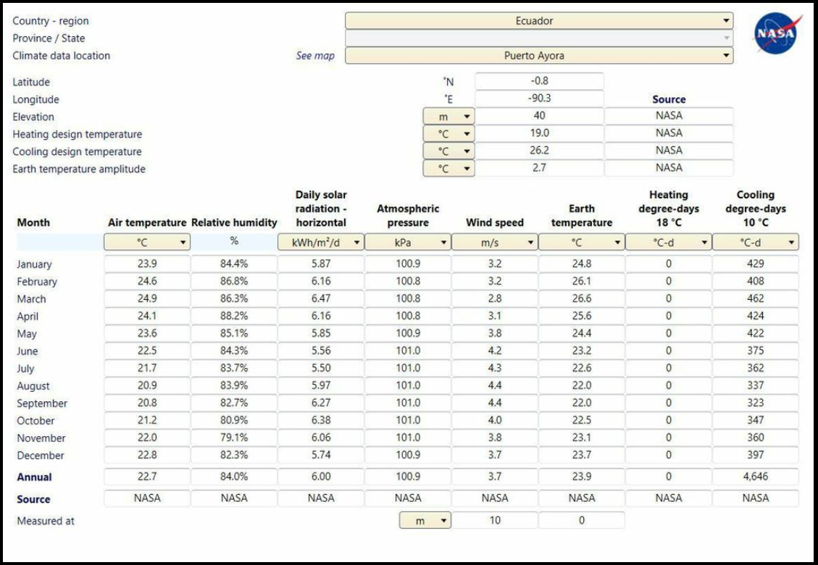

Source: nasa.gov, ‘NASA Surface meteorology and Solar Energy’ 2014

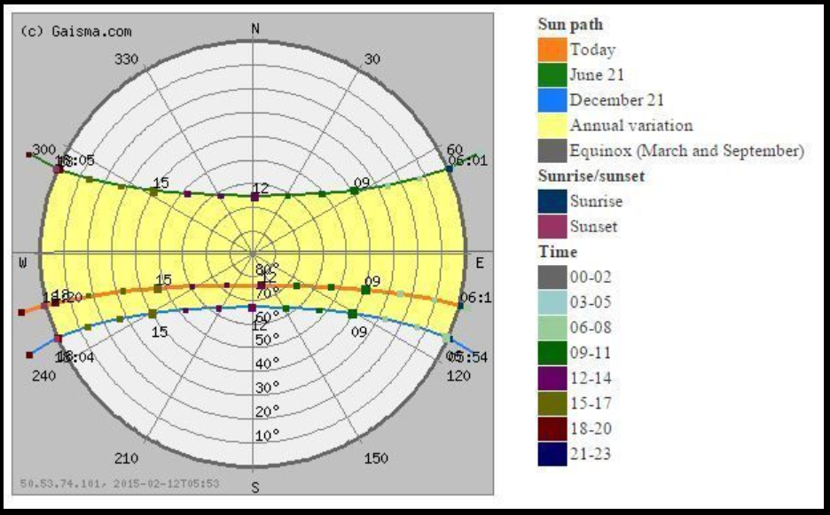

Bill of Materials A3

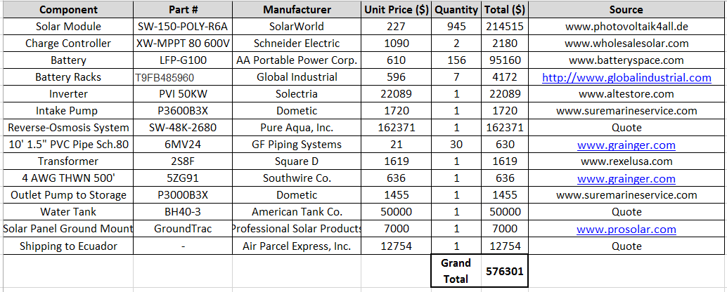

System Layout A4

